PROBLEM: 1. Write a C++ program to delete an array element using its index number.
CODE:
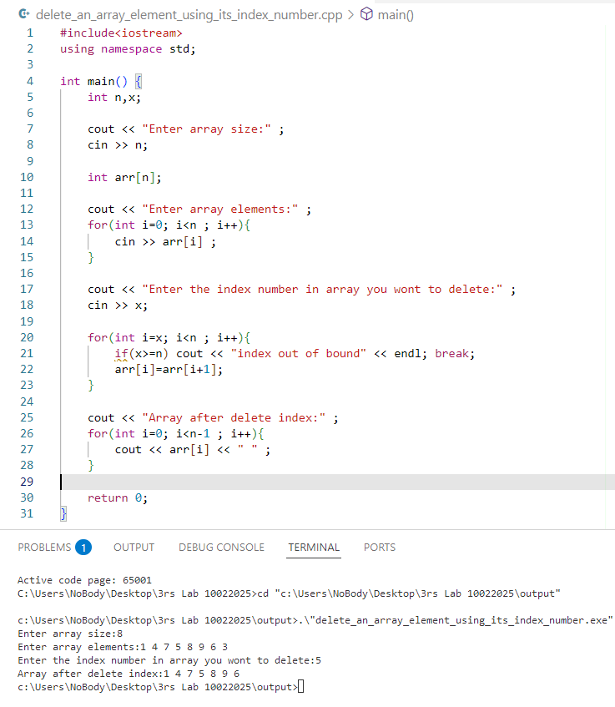

PROBLEM: 2. Write a C++ program to delete an array element by its value using linear search.
CODE:
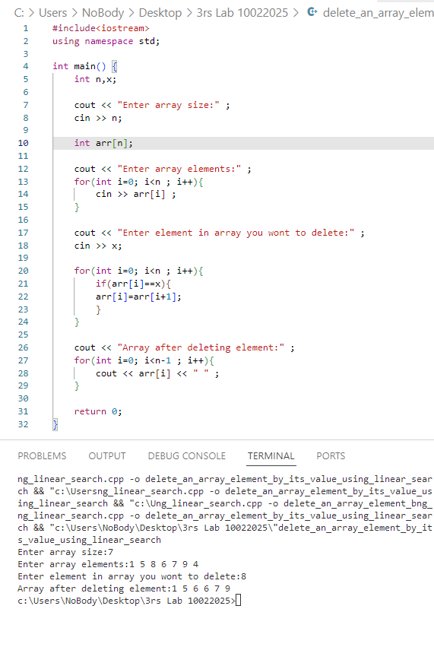
PROBLEM: 3. Write a C++ program to perform a binary search on an array.
CODE:
